**RUSSIAN BIAS**

*«We know what we are, but we do not know what we can be*»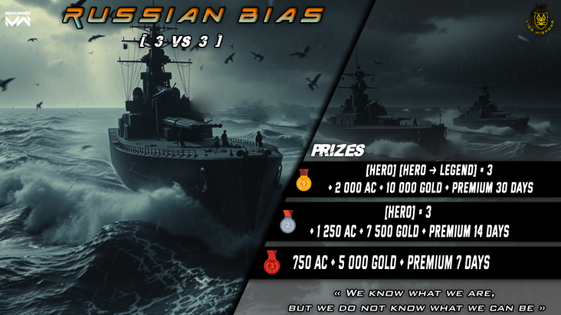

INDEX:

1. TOURNAMENT DESCRIPTION
2. PRIZES
3. TOURNAMENT FORMAT
4. LIMIT DATES
5. RULES

REGULATION

1. TOURNAMENT DESCRIPTION

* Competition method: 3 vs 3
* Ships to use:

1. RF TARK Pyotr Velikiy
2. RF Admiral Nakhimov
3. RF TARK Kirov

* Level of weapons to use: T3 ONLY
* Number of participating teams: 32
* Duration: 1 month
* Type: worldwide
* Format: Simple Elimination
* Everyone can participate. Maximum 1 Legendary per team. No limit for heroes.

1. PRIZES

**1° Place**

***[HERO] [HERO ➔ LEGEND]*3 + 2 500 AC + 15 000 Gold + Premium 30 days***

**2° Place**

***[HERO]*3 + 1 500 AC + 10 000 Gold + Premium 14 days***

**3° Place**

***1 000 AC + 5 000 Gold + Premium 7 days***

1. TOURNAMENT FORMAT

The *“Russian Bias”* tournament will be based on the simple elimination system. In which the teams will be divided into 4 groups as follows:

* **GROUP A-B:** teams from Asia, Europe, Africa and Oceania.
* **GROUP C-D:** teams from America.

The winner of each round of the **GROUP STAGE** will be awarded the victory under the *'Best of 3 (Bo3)'* format. For the **FINAL STAGE** **(semifinals, 3rd place and final of the entire tournament)** will be assigned the *'Best of 5 (Bo5)'* format. For these formats the following maps were selected in order:

* **Bo3:**

*Strom old → Storm new → Unexplored Rocks*

* **Bo5:**

*Only in 'Storm' (old version)*

1. LIMIT DATES

UTC will be selected as general time. The start of registration will begin immediately after the announcement of the tournament. Registration will be available until **-** or until all places are filled.

* Start: Thursday January 02nd, 2025
* End: Friday January 17th, 2025

1. RULES
2. Players are prohibited from hiding their nickname and title, if they do, they will automatically lose the match. Hero/Legendary players are only allowed to use these titles, using any other will be considered as "hiding" their title and will result in a penalty. (3/5 matches = 1 round)
3. Players who obtain either of the 2 titles after registering for our tournament must inform the organizers.
4. **Maximum 1 Legendary per team. No limit for heroes.**
5. Duration of each match: 10 minutes.
6. **Formation to follow:**
7. **RF TARK Pyotr Velikiy**
8. **RF Admiral Nakhimov**
9. **RF TARK Kirov**

***Note: IT IS MANDATORY TO USE EACH OF THESE SHIPS.***

1. **ONLY THE USE OF RUSSIAN WEAPONS (STORE and BP) IS ALLOWED.**
2. The following ships and weapons are prohibited:

* **ALL ITEMS THAT ARE NOT FROM RUSSIA.**
* **ALL ITEMS ARE EXCLUSIVE TO THE MARKET AND GACHA (likes mantis 30D, Iskander, Mi-8tv, etc).**
* **ZIRCON**
* **Weapons and ships T1 and T2.**

1. The use of items from the above list is prohibited. Violation of this rule is punishable by losing the match. (3/5 matches = 1 round)
2. For the first match, the waiting time for the teams to enter the room is a maximum of 10 minutes. Starting from the second match, the waiting time will be reduced to 5 minutes.
3. The day and time of the fight is established by the teams themselves within the deadline established by the organization. If an agreement is not reached, the organizers have the complete right to impose any time for the battle on said teams.
4. The use of illegal third-party software, including plug-ins, scripts and linkers, is not allowed by the competition.
5. Players are prohibited from participating in intentional omissions such as "fights" and receiving payment from other teams. In addition to being placed on the rogue player list, offenders will be banned from the current tournament.
6. Before the match starts, a judge will inform the team captains about the hall identification.
7. **The team can change its formation of players before the start of the tournament. AFTER the start of the tournament, player changes will NOT be accepted.**
8. The Alpha and Bravo side for each team will be decided by the judge in charge.
9. Captains or players are requested to be ready at least 10 minutes before the scheduled match time and report their presence. Any intentional delay will lead to an automatic loss and disqualification from the tournament.
10. If a team does not enter the first room during the 10 minutes wait, the opponent will receive the default victory for the entire round (1 round = 3/5 matches). If both teams do not arrive, they will be disqualified, except for the Final and 3rd Place.
11. If due to unknown problems a team does not have its 3 players for the battle, it is allowed to play in the following formats: 2vs3 and 2vs2.
12. **Only 1 rematch will be given in the entire round due to game bug/glitch or disconnection. In case of errors inherent to the game, you must provide some evidence that demonstrates the problem to help the judge make the best possible decision. On the other hand, due to a disconnection, it will only be taken into account if it occurs during the 1st minute of play. To do this, the captain must provide evidence so that the judge can order a rematch.**
13. During a rematch, players are required to use the same ships and the same equipment. Their output sides (Alpha or Bravo side) will remain the same. There can be no more than 2 rematches per round. This includes only 1 rematch per team per round.
14. If a player is out of the game when a match starts, they must report this within the first minute of the fight. Said player has the opportunity for a rematch after the approval of the judge.
15. **In case of a Draw in the result of the match, the winner will be decided depending on the following cases: a) The team with the most members alive will be the winner of the match; b) If the number of survivors on both sides is the same, the winner will be decided by the most dmg; c) If the last players die at the same time, the winner will be decided based on the most dmg caused; d) If the last players die, but there is a clear difference in the time of death, the victory will go to the one who survived the longest.**
16. A clan is not required for a player to participate in the tournament. A team can be made up of players from different clans.
17. The team that refuses to play again at the request of the organizer receives a technical defeat. Excessive and pedantic arguments with the organizers/judges will result in permanent suspension of the teams from the tournament.
18. A player or team will have the right to challenge a decision made by the staff (Judge and/or Recorder), but not the decisions made by the organizers.
19. Players are prohibited from participating in intentional omissions such as "fights" and receiving payment from other teams. In addition to being placed on the rogue player list, offenders will be banned from the current tournament.
20. The player is prohibited from changing the game account. He/she can participate in the tournament only from your registered account.
21. A player is prohibited from playing with two or more teams at the same time. Such an action would be extremely unacceptable and would be considered fraud.
22. Sharing of game account login and password details is prohibited. Any form of account manipulation will be considered a serious violation of the tournament rules.
23. It is prohibited to use secondary accounts to participate in the tournament. Such an action will be severely penalized with a permanent ban from the server and informing the developers so that they can also take action.
24. Any use of game errors to gain a decisive advantage will result in a technical defeat for the team. In extreme cases, the player and the team can be expelled from the tournament.
25. If the above rules are incomplete or ambiguous, the organizers will have the right to make a final decision according to the situation or controversy generated.

Competitors are expected to participate honorably, study the competition, carefully review the rules, and refrain from using illegal watercraft, accessories, weapons, or any other prohibited weapons. The team and players will issue warnings to violators once.

By:

* Organizers: **rene6184** ~ **kami_unk**
* Original idea by:**trigger_mg**